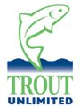

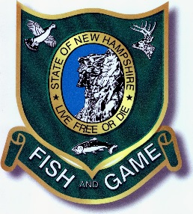
AMMONOOSUC TROUT UNLIMITED
Young Trout; Young Science EAS Project
Project Report Number 5- September 17, 2018
Summary of 2018 Field Activities To Date
A. Background. This report is directed to all persons or organizations interested in, or who have contributed to the “Young Trout; Young Science” project, sponsored by the Ammonoosuc Chapter TU, as a co-operative effort between Trout Unlimited, New Hampshire Fish and Game, and Dartmouth College. It has been funded by a Wildlife Heritage Foundation of NH grant, by in-kind and financial contributions from Dartmouth College, by an Embrace A Stream grant from the Trout Unlimited national organization, by additional funds received through contributions from 10 Trout Unlimited Chapters and Councils in Maine, New Hampshire, and Massachusetts, and by individual donations from over 100 other organizations and individuals. For previous reports and information concerning this project, go to www.ammotu.org.
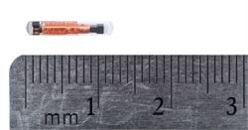
Field activities in 2018 have been directed at three goals: (1) Capturing, tagging, and tracking at least 500 small wild Eastern brook trout (“EBT”), including “young of the year” fish from a tributary of the Dead Diamond River, Loomis Valley Brook (“LVB”) located in the Second Dartmouth College Grant; (2) Developing equipment and methods utilizing extremely small tags (8 mm and 12 mm “PIT” tags), which are surgically implanted, and then tracking these small trout with stationary receivers on stream banks or with portable “wands” to determine the movement patterns of these fish over an entire season. The data thus obtained will potentially permit
12 MM PIT TAG
scientists and fisheries managers to determine what role LVB plays in contributing to the EBT population in larger mainstem rivers (the Dead Diamond, Swift Diamond, and Magalloway River in Maine and New Hampshire); (3) Continue monitoring, observations, and habitat measurements to determine the location of major spawning areas, spawning patterns (where, when, and why do trout spawn where they do in the system), and the role played by groundwater temperatures and seepage into the rivers in these patterns. This year, Dianne Timmins, of NH Fish and Game and Keith Fritschie, a PhD student from Dartmouth, have continued to work on the project with assistance from Glenn Booma and two seasonal field technicians who are working full time from May 15-November 15 at the Grant thanks to funding from Trout Unlimited, your individual contributions, and accommodations and other support provided by Dartmouth College.
B. Tagging and Tracking Activities. Field activities to capture, tag, and track small EBT began around May 15, 2018 as soon as weather and water levels would permit. Unfortunately, as occurred in 2017, we experienced delays in being able to capture and tag fish due to significant equipment and weather related problems. This was our first attempt—and we believe one of the first projects in the country—to utilize the smallest available tags (8mm/0.32”) to track tiny young-of-the-year trout down to 36mm (1.4”) in length and challenges were thus not unexpected. Significant problems were encountered in getting receiver equipment to work, getting the equipment manufacturers to replace defective equipment, building antennae arrays that would work with the equipment, determining what arrays and what placement of arrays at the research site worked best, dealing with two major storms that caused significant flooding that interfered with operations, and either displaced or damaged antennae and other equipment, and training new interns and personnel how to use the equipment and to properly tag and track fish. While these challenges contributed to a delay in tagging new fish until July 13, 2018, detection of fish tagged during 2017 was successfully conducted beginning in late May.
The good news is that most of these problems have been overcome and between July 13, 2018 and August 19, 2018, 536 new fish were captured and tagged, and tracking of these fish has been ongoing during this period of time. This is in addition to the 644 trout captured and tagged in 2017, so the project has now succeeded in capturing and tagging over 1150 trout.
1. Sponsor Assignments.
Attached is an Excel spreadsheet showing the date, tagging location, length, size, and tag number of all fish tagged in 2018 through August 19, 2018. Also, in recognition of the many organizations and individuals who have contributed to the support of this project, each person or group who contributed to the project either during the EAS online fundraising event in November 2017, or at any time in 2018, has been assigned as Sponsor to a number of fish.
Go to the “Sponsor” column (Column I) to see to which fish you or your organization has been assigned as sponsor. To locate where your fish was captured and tagged (1) Go to Google Earth or any other online map service and locate the confluence of LVB and the Dead Diamond River at Latitude N44.9232 (N44 ◦ 55’ 24”) Longitude W71.0936 (W71◦ 05” 37”).

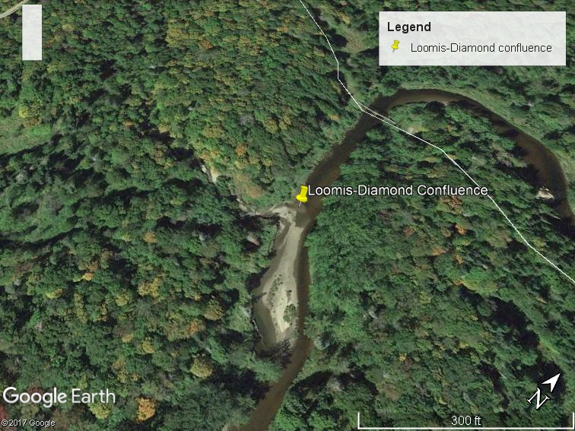
(2) From Column E on the spreadsheet entitled “Initial Tagging- Meters Upstream From Confluence” read the number of meters upstream that your fish was captured and tagged. (1 meter = 3.28084 feet.).
(3) Use the “Dropped Pin’ function on Google Earth to measure this distance upstream from the confluence to see where your fish was tagged.
Please note that additional fish have been tagged since August 19, and tagging activities will continue into the fall. Additional sponsors will be assigned as data on these fish are processed, and will be reported in subsequent Project Reports. In addition, since we are now tracking these fish to determine movement, thousands of data points are being received and processed. As we did last year, movement data will be reported to sponsors and interested parties after the field season is finished in mid-November. Be sure to note the PIT Tag Number of your fish. In the future, movement data will be reported by Fish Number and PIT Tag Number.
Note the length and weight of your fish as reported in columns G and H of the spreadsheet. If your fish is 85 mm or less in length, it was probably tagged with an 8 mm tag and has a good likelihood of being a “Young of the Year” (“YOY”) first year fish. So that expectations are not too high, these fish have a low survival rate and more than half may not be detected again. This is one of the reasons we tag so many of these fish, so we can be sure of getting data on a statistically adequate number. That said, we have tracking data on many YOY showing that they have moved several hundred meters (yards) already and the fall spawning season, which usually results in an increase in migration and movement, is just beginning. Stay tuned for more information about your fish!
For those who were assigned as sponsors to fish tagged in 2017 (See Project Repot No. 4 with spreadsheet) you may be interested to know that through August 19 we have been able to locate only about 30 of the 644 fish tagged last year. Location and movement data on fish tagged in 2017 will be reported after the end of the 2018 field season.
C. Spawning and Temperature Studies. Studies are continuing in 2018 to determine the locations of major spawning areas, to determine (1) whether any tagged fish from LVB are utilizing Dead Diamond River spawning sites; (2) why brook trout select specific sites to spawn; (3) how the temperature of ground water seeping into the stream affects site selection and the distribution and use of redds within a spawning site, and; (4) the potential effect of ground water on hatch timing and survival of young of year fish in the spring. Keith Fritschie, a Dartmouth PhD student, is leading this effort. This August Keith measured river velocity, substrate size, water depth, and riverbed temperature at ~1200 points in 8 spawning patches that he identified via snorkel survey last fall. He also deployed 30 continuous temperature loggers in the riverbed in 5 patches to monitor the dynamics of surface water and groundwater temperatures in relation to the spawning and egg incubation periods. These data will be coupled with redd location data to determine habitat requirements of spawning brook trout and to estimate the developmental consequences of redd site choice for developing offspring. The most important time of year for this effort is the fall spawning season, which is just about to begin, so Keith will be “in residence” at the Grant from the last part of September until well into November, working on a daily basis. For a report of Keith’s work and findings in 2017, and to see some of the fantastic underwater videos of large spawning brook trout that he obtained, see Project Report No. 4 at the Ammonoosuc TU website, www.ammotu.org. A detailed report of Keith’s work and findings in 2018 will be provided in a future project report.
D. TU Outreach Activities. A number of outreach activities have occurred in 2018 to date. Robert Piampiano, Project Director, Glenn Booma, Field Co-coordinator, and two of the project field technicians hired to work, gave a presentation about the project and TU’s work and mission to a group of over 100 people at a meeting of the Rangeley Guides and Sportsman’s Association in May 2018, which resulted in a further generous donation from that group. Additional outreach activities have been done by Ammo TU officers Ron Ouellette and Art Greene resulting in major contributions from Tender Corporation, FedEx, and other sponsors. A major contribution has also been received in support of the project from Brookfield Renewable Energy that has helped to pay for expensive electronic equipment used on the project. Thanks to these donors and the many others who have contributed during the online funding effort in November 2017 or in 2018.
Two volunteer events have been held to date on July 13 and August 17-20 that have allowed volunteers to get into the water at the LVB research site and help with fyke netting, electrofishing, and tagging and tracking of fish. Over 50 volunteers helped with project work at these events.
And, on September 21-23, 2018 over 30 donor representatives and project staff will meet at the Second College Grant for the weekend to learn about project activities, to visit project sites, and to help with project work.
Dartmouth College also plans to hold a conference in late fall 2018 or early 2019 that will offer an opportunity for all persons doing research, or interested in research, at the Grant to share and discuss findings and exchange ideas. Dianne Timmins, Keith Fritschie, and others will be making presentations at this conference concerning Project activities and findings. Any person or organization wishing to attend the conference may contact Robert Piampiano at rjpiampiano@gmail.com to receive information about dates and attendance.
E. Future Project Reports/Contributions. Interested parties may expect that the next significant project report will come out in February or March 2019 after data analysis and findings from the 2018 field season have been completed. This report will contain information about tracking and movement of fish assigned to individual sponsors. Prior to this report, you may receive additional updates on fish tagged and sponsors assigned after August 19. In the meantime, if there ae any questions, please feel free to contact Robert Piampiano at the above email address or at 207-831-9232. Anyone wishing to contribute to the project may do so by contacting Robert Piampiano or going to the Ammonoosuc TU website at www.ammotu.org.

Attachment: 2018 Data-Sponsor Assignments Through August 19, 2018- Excel Spreadsheet.

