Ammonoosuc River Stream Crossing Assessment Project
FACT SHEET
What is it? The Ammonoosuc River Stream Crossing Assessment Project (ARSCAP) aims to assess all stream crossings within the Ammonoosuc River Watershed and evaluate aquatic habitat connectivity data during the summer/fall of 2016. This information will be used to rate each culvert for its aquatic organism passage (AOP). Trout Unlimited National is serving as project supervisor, providing technical expertise and support. NH Fish & Game Department biologists are providing technical assistance. Plymouth State University’s Center for Business & Community Partnerships faculty and interns are conducting culvert assessments and community outreach. The Ammonoosuc Chapter of Trout Unlimited is providing volunteer assistance during site assessments, community engagement and landowner outreach.
Why does it matter? The Ammonoosuc River Watershed spans an area of approximately 400 square miles from the Lake of the Clouds to its confluence with the Connecticut River in Woodsville. The watershed has a tremendous diversity of terrestrial and aquatic habitats, including forest, wetlands, small streams and open space that support a variety of critical wildlife, as well as a variety of recreational hot spots for people. More than 15 resident cold- and warm water fish species and several threatened or endangered wildlife species are found here. There are approximately 720 stream crossings in this watershed. Properly sized and installed culverts enable wildlife to access critical habitats that are located up- or downstream and they are less vulnerable to damage during storm events.
How will it help the communities within the watershed? By understanding the condition of culverts across the entire watershed, communities, state agencies and conservation organizations will have the information needed to conduct successful culvert replacement projects that will improve infrastructure resilience and ecological connectivity. An understanding of this depth will also strengthen the relationship between various grant applicants/partnerships opening up a variety of opportunities from different funding sources.
How can residents get involved? Is there a troublesome culvert that you’d like us to know about? Are you curious about the condition of culverts in your town? We invite you to call us or even join us in the field for a day! Interested volunteers are encouraged to contact Rachelle Lyons.

Thanks to the Upper Connecticut River Mitigation and Enhancement Fund for supporting this work. Special Thanks to NH DES, UNHT2 and NH DOT for collaborating on this project.

For more information contact: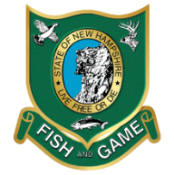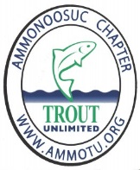
Colin Lawson Trout Unlimited Project Supervisor clawson@tu.org
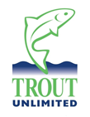

Rachelle Lyons Plymouth State University Project Manager rllyons@plymouth.edu 603 412-2694

